Project Design Phase
Solution Architecture

Date | 30 September 2026
Team ID | SWTID-2026-7764
Project Name | Import Data using Transform Maps (Spreadsheet)
Maximum Marks | 4 Marks

Solution Architecture for Employee Data Import
The architecture uses an XLSX source, ServiceNow Import Set staging, a Transform Map, a custom target table, and native reports/dashboard. Employee ID coalesce controls repeated imports. The model uses five String fields and no external integration is specified.
- The design follows the supplied nine-phase implementation walkthrough and groups the work into four dashboard milestones.
- The spreadsheet is loaded to Employee Import (u_employee_import), mapped by Sample Spreadsheet Import, and transformed into Employee Test (u_employee_test).
- The core controls are four same-name field maps plus Name → Employee Name, Employee ID coalesce, transform history review, three reports, and controlled dashboard sharing.
- Figure 1 shows the end-to-end project architecture. Use the source walkthrough for UI steps and the requirements document for field/report details.

Project data flow: spreadsheet → Employee Import staging → Sample Spreadsheet Import with five field maps and Employee ID coalesce → Employee Test → Department/Location/list reports → Employee Analytics Dashboard. Share the dashboard with the intended users, groups, or roles.

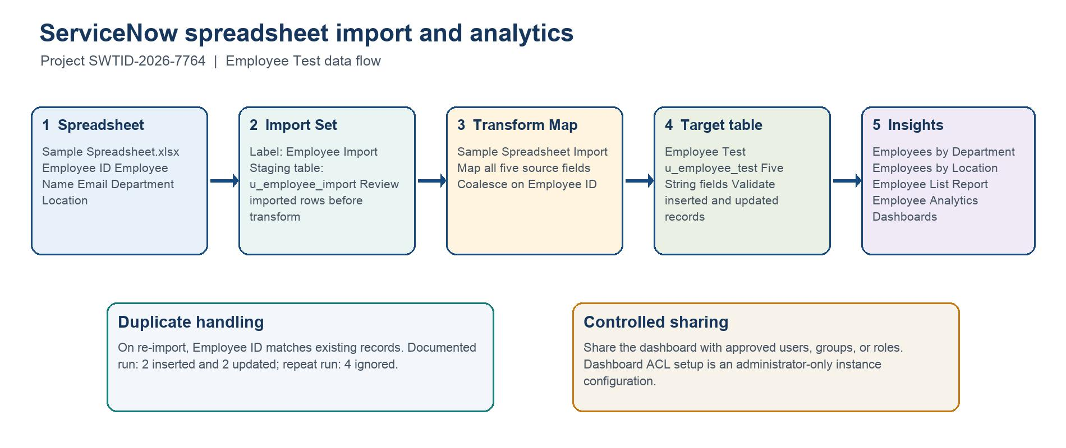
Figure 1. Employee spreadsheet → Employee Import → Sample Spreadsheet Import with Employee ID Coalesce → Employee Test → reports and Employee Analytics Dashboard.
Source: supplied Import Data using Transform Maps.docx walkthrough; dashboard sharing is configured for intended users, groups, or roles.

